**CONFIGURING BORDER GATEWAY PROTOCOL WITH EIGRP AND OSPF**



***BY: ALEKSIE SANCHEZ MEDEIROS***

**

***Purpose***

To learn how to configure OSPF and EIGRP in conjunction with BGP among 6 point-to-point routers on a network.

***Background***Enhanced Interior Gateway Protocol [EIGRP] is a distance vector routing protocol that uses ‘old’ distance vector routing algorithms to determine the best possible route for traffic on a network, removing the need to manually configure routes. It’s also a Cisco proprietary protocol that is only available on Cisco routers as compared to OSPF which can be used on routers from other vendors, although Cisco has allowed some vendors to use a version of EIGRP that suffers from limitations that Cisco has kept for its own routers. EIGRP is a replacement for Cisco-proprietary Interior Gateway Routing Protocol [IGRP]. IGRP was created to overcome the limitations created by Routing Information Protocol [RIP] such as its limited scalability and its use of hops as its only metric. IGRP would use the bandwidth, delay, the load or work, and the reliability of the connection to determine the best possible routes. It does however suffer from some issues, one of which is that updates are constantly sent across the entire network frequently causing large amounts of traffic. The most major issue is that IGRP also uses old classful routing, this causes multiple issues with the modern IP addressing allocation that uses variable length subnet masks to mitigate rapid depletion of IPv4 addresses. To fix these issues EIGRP was created to allow for classless IPv4 addresses and would only send updates to other routers whenever a change was created to the network's topology, in comparison to sending entire routing tables. When EIGRP is completely set up, routers will attempt to exchange information with each other until an adjacency is formed, once created only changes to the network are communicated between those routers. Furthermore, because of its usage of distance-vector routing, EIGRP is backwards compatible with IGRP.

Open Shortest Path First [OSPF] is another routing protocol which automates the process of manual configuration of routes by a network administrator. In addition, OSPF uses a link state routing algorithm to determine the best path for traffic. OSPF uses changes in topologies similar to EIGRP but instead focuses on inter router communication on the connectivity between two routers. Each individual router calculates its own routing table based on these messages and creates the best path to each router individually.

Border Gateway Protocol [BGP] is different from the rest of the previously mentioned routing protocols in that BGP is an exterior gateway protocol while OSPF and EIGRP are interior gateway protocols. Interior gateway protocols are primarily used inside of local area networks and are used for routing inside the same autonomous system [AS]. An exterior gateway protocol is like an interior gateway protocol in that it automates routing but is different in that it automates routing between different autonomous systems.. An autonomous system is basically a network or group of networks that are all put together under one umbrella with an autonomous system number [ASN], which is an identifier to be used with BGP routing. BGP itself uses a path-vector routing protocol that makes decisions based on the paths, rules and policies set by network administrators.   
  
BGP itself uses path-vector messages to update its routing table with the destination network, next hop router and the path necessary to reach its destination. As the message goes through a router participating in BGP, the router will add its own ASN to the message, and replace the next hop router entry with the information of the first BGP router. To establish and maintain connections between other routers, called peers, BGP sends small ‘hello’ messages. BGP can be run using the same autonomous system number between routers (internal BGP). Routers that are using both BGP and another protocol are referred to as autonomous system boundary routers and are very important in distributing routes from BGP to the AS or from the AS to BGP.

***Lab summary***

At the end of the lab, there was IPv4 and IPv6 connectivity between autonomous systems that are using OSPF and EIGRP, using BGP to share routes across the whole network.

***Lab Commands***

**router bgp** [asn] - is used to start the BGP process and to configure BGP process and ASN

***neighbor*** *[ip-address]* ***remote-as*** *[asn]* - is used to allow for communication between the router and it’s neighbor  
***address-family******ipv4*** - used to initialize address family process for BGP for ipv4  
***address-family******ipv6*** - used to initialize address family process for BGP for ipv6

***neighbor*** *[ip-adress]* ***activate*** - used to activate the BGP neighbor  
***router eigrp*** *[asn]* - is used to start the EIGRP process and to configure EIGRP process and ASN  
***network*** *[network-address] [wildcard-mask]* - is used to specify the range of addresses that will participate in EIGRP address sharing

***Network Diagram***

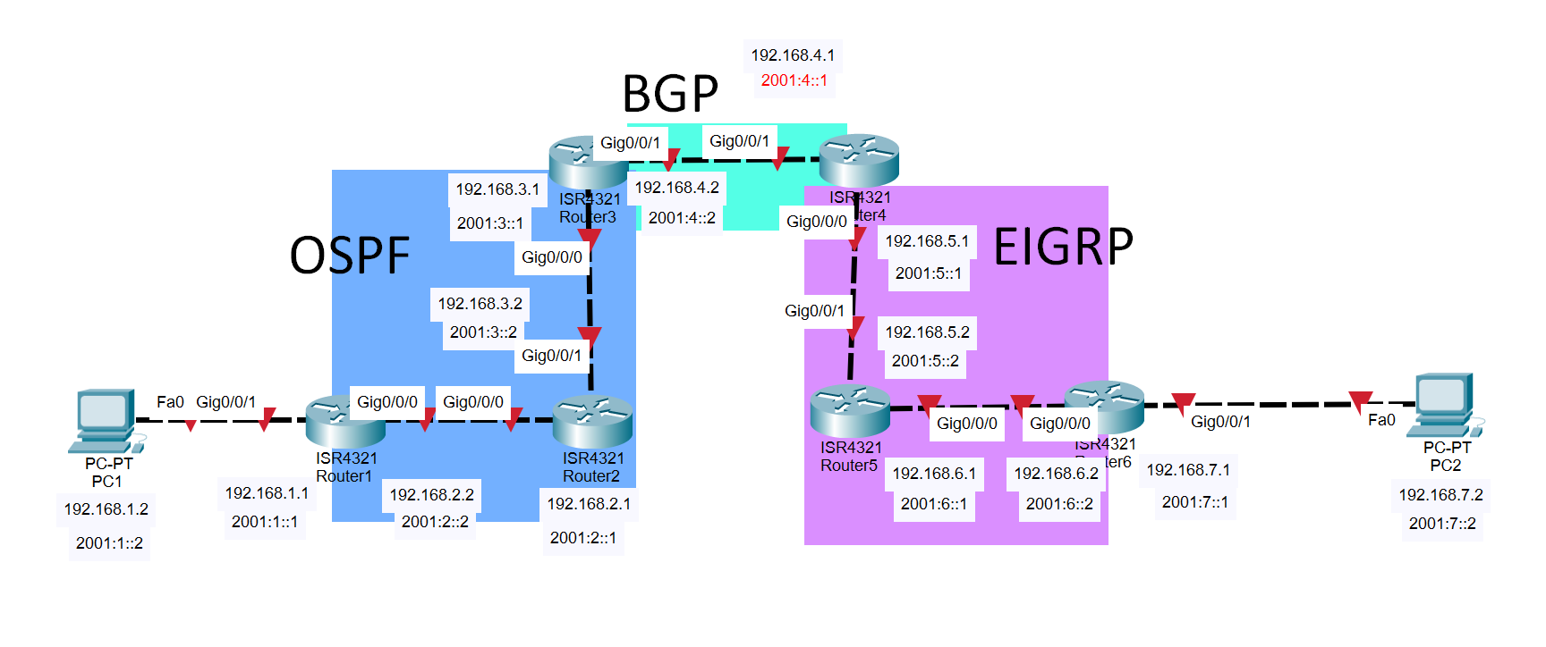  
***Router Configurations***

***R1:***

***Last configuration change at 20:32:14 UTC Fri Oct 21 2022***

***version 15.5***

***service timestamps debug datetime msec***

***service timestamps log datetime msec***

***no platform punt-keepalive disable-kernel-core***

***hostname R1***

***boot-start-marker***

***boot-end-marker***

***vrf definition Mgmt-intf***

***address-family ipv4***

***exit-address-family***

***address-family ipv6***

***exit-address-family***

***no aaa new-model***

***ipv6 unicast-routing***

***subscriber templating***

***multilink bundle-name authenticated***

***license udi pid ISR4321/K9 sn FDO214811ZM***

***spanning-tree extend system-id***

***redundancy***

***mode none***

***vlan internal allocation policy ascending***

***interface GigabitEthernet0/0/0***

***ip address 192.168.2.2 255.255.255.0***

***negotiation auto***

***ipv6 address 2001:2::2/64***

***ipv6 ospf 1 area 0***

***interface GigabitEthernet0/0/1***

***ip address 192.168.1.1 255.255.255.0***

***negotiation auto***

***ipv6 address 2001:1::1/64***

***ipv6 ospf 1 area 0***

***interface Serial0/1/0***

***no ip address***

***shutdown***

***interface Serial0/1/1***

***no ip address***

***shutdown***

***interface GigabitEthernet0/2/0***

***no ip address***

***shutdown***

***negotiation auto***

***interface GigabitEthernet0/2/1***

***no ip address***

***shutdown***

***negotiation auto***

***interface GigabitEthernet0***

***vrf forwarding Mgmt-intf***

***no ip address***

***shutdown***

***negotiation auto***

***interface Vlan1***

***no ip address***

***shutdown***

***router ospf 1***

***router-id 1.1.1.1***

***network 192.168.1.0 0.0.0.255 area 0***

***network 192.168.2.0 0.0.0.255 area 0***

***ip forward-protocol nd***

***no ip http server***

***no ip http secure-server***

***ip tftp source-interface GigabitEthernet0***

***ipv6 router ospf 1***

***router-id 1.1.1.1***

***control-plane***

***line con 0***

***stopbits 1***

***line aux 0***

***stopbits 1***

***line vty 0 4***

***login***

***end***

***R2:***

***Last configuration change at 20:57:28 UTC Fri Oct 21 2022***

***version 15.5***

***service timestamps debug datetime msec***

***service timestamps log datetime msec***

***no platform punt-keepalive disable-kernel-core***

***hostname R2***

***boot-start-marker***

***boot-end-marker***

***vrf definition Mgmt-intf***

***address-family ipv4***

***exit-address-family***

***address-family ipv6***

***exit-address-family***

***no aaa new-model***

***ipv6 unicast-routing***

***subscriber templating***

***multilink bundle-name authenticated***

***license udi pid ISR4321/K9 sn FDO214414TX***

***spanning-tree extend system-id***

***redundancy***

***mode none***

***vlan internal allocation policy ascending***

***interface GigabitEthernet0/0/0***

***ip address 192.168.2.1 255.255.255.0***

***negotiation auto***

***ipv6 address 2001:2::1/64***

***ipv6 ospf 1 area 0***

***interface GigabitEthernet0/0/1***

***ip address 192.168.3.2 255.255.255.0***

***negotiation auto***

***ipv6 address 2001:3::2/64***

***ipv6 ospf 1 area 0***

***interface Serial0/1/0***

***no ip address***

***shutdown***

***interface Serial0/1/1***

***no ip address***

***shutdown***

***interface GigabitEthernet0/2/0***

***no ip address***

***shutdown***

***negotiation auto***

***interface GigabitEthernet0/2/1***

***no ip address***

***shutdown***

***negotiation auto***

***interface GigabitEthernet0***

***vrf forwarding Mgmt-intf***

***no ip address***

***shutdown***

***negotiation auto***

***interface Vlan1***

***no ip address***

***shutdown***

***router ospf 1***

***router-id 2.2.2.2***

***network 192.168.2.0 0.0.0.255 area 0***

***network 192.168.3.0 0.0.0.255 area 0***

***ip forward-protocol nd***

***no ip http server***

***no ip http secure-server***

***ip tftp source-interface GigabitEthernet0***

***ipv6 router ospf 1***

***router-id 2.2.2.2***

***control-plane***

***line con 0***

***stopbits 1***

***line aux 0***

***stopbits 1***

***line vty 0 4***

***login***

***end***

***R3:***

***Last configuration change at 21:58:11 UTC Fri Oct 21 2022***

***version 15.5***

***service timestamps debug datetime msec***

***service timestamps log datetime msec***

***no platform punt-keepalive disable-kernel-core***

***hostname R3***

***boot-start-marker***

***boot-end-marker***

***vrf definition Mgmt-intf***

***address-family ipv4***

***exit-address-family***

***address-family ipv6***

***exit-address-family***

***no aaa new-model***

***ipv6 unicast-routing***

***subscriber templating***

***vtp domain cisco***

***vtp mode transparent***

***multilink bundle-name authenticated***

***license udi pid ISR4321/K9 sn FDO214328EH***

***spanning-tree extend system-id***

***redundancy***

***mode none***

***vlan internal allocation policy ascending***

***interface GigabitEthernet0/0/0***

***ip address 192.168.3.1 255.255.255.0***

***negotiation auto***

***ipv6 address 2001:3::1/64***

***ipv6 enable***

***ipv6 ospf 1 area 0***

***interface GigabitEthernet0/0/1***

***ip address 192.168.4.2 255.255.255.0***

***negotiation auto***

***ipv6 address 2001:4::2/64***

***ipv6 enable***

***interface Serial0/1/0***

***no ip address***

***shutdown***

***interface Serial0/1/1***

***no ip address***

***shutdown***

***interface Service-Engine0/2/0***

***no ip address***

***shutdown***

***interface GigabitEthernet0***

***vrf forwarding Mgmt-intf***

***no ip address***

***shutdown***

***negotiation auto***

***interface Vlan1***

***no ip address***

***shutdown***

***router ospf 1***

***router-id 3.3.3.3***

***redistribute bgp 1 subnets***

***network 192.168.3.0 0.0.0.255 area 0***

***router bgp 1***

***bgp router-id 3.3.3.3***

***bgp log-neighbor-changes***

***neighbor 2001:4::1 remote-as 1***

***neighbor 192.168.4.1 remote-as 1***

***address-family ipv4***

***bgp redistribute-internal***

***network 192.168.3.0***

***network 192.168.4.0***

***redistribute ospf 1 match internal external 1 external 2***

***no neighbor 2001:4::1 activate***

***neighbor 192.168.4.1 activate***

***exit-address-family***

***address-family ipv6***

***redistribute connected***

***redistribute ospf 1 match internal external 1 external 2***

***bgp redistribute-internal***

***network 2001:3::/64***

***network 2001:4::/64***

***neighbor 2001:4::1 activate***

***neighbor 2001:4::1 advertise best-external***

***exit-address-family***

***ip forward-protocol nd***

***no ip http server***

***no ip http secure-serverr***

***ip tftp source-interface GigabitEthernet0***

***ipv6 router ospf 1***

***router-id 3.3.3.3***

***redistribute connected***

***redistribute bgp 1 metric 1000000***

***control-plane***

***line con 0***

***stopbits 1***

***line aux 0***

***stopbits 1***

***line vty 0 4***

***login***

***end***

***R4***

***Last configuration change at 21:42:23 UTC Fri Oct 21 2022***

***version 15.5***

***service timestamps debug datetime msec***

***service timestamps log datetime msec***

***no platform punt-keepalive disable-kernel-core***

***hostname R4***

***boot-start-marker***

***boot-end-marker***

***vrf definition Mgmt-intf***

***address-family ipv4***

***exit-address-family***

***address-family ipv6***

***exit-address-family***

***no aaa new-model***

***ipv6 unicast-routing***

***subscriber templating***

***vtp domain cisco***

***vtp mode transparent***

***multilink bundle-name authenticated***

***license udi pid ISR4321/K9 sn FDO210907U3***

***spanning-tree extend system-id***

***redundancy***

***mode none***

***vlan internal allocation policy ascending***

***interface GigabitEthernet0/0/0***

***ip address 192.168.5.1 255.255.255.0***

***negotiation auto***

***ipv6 address 2001:5::1/64***

***ipv6 enable***

***ipv6 eigrp 1***

***interface GigabitEthernet0/0/1***

***ip address 192.168.4.1 255.255.255.0***

***negotiation auto***

***ipv6 address 2001:4::1/64***

***ipv6 enable***

***interface Serial0/1/0***

***no ip address***

***shutdown***

***interface Serial0/1/1***

***no ip address***

***shutdown***

***interface GigabitEthernet0/2/0***

***no ip address***

***shutdown***

***negotiation auto***

***interface GigabitEthernet0/2/1***

***no ip address***

***shutdown***

***negotiation auto***

***interface GigabitEthernet0***

***vrf forwarding Mgmt-intf***

***no ip address***

***shutdown***

***negotiation auto***

***interface Vlan1***

***no ip address***

***shutdown***

***router eigrp 1***

***network 192.168.4.0***

***network 192.168.5.0***

***redistribute bgp 1 metric 1000000 10 255 1 1500***

***redistribute connected***

***eigrp router-id 4.4.4.4***

***router bgp 1***

***bgp router-id 4.4.4.4***

***bgp log-neighbor-changes***

***neighbor 2001:4::2 remote-as 1***

***neighbor 192.168.4.2 remote-as 1***

***address-family ipv4***

***bgp redistribute-internal***

***network 192.168.4.0***

***network 192.168.5.0***

***redistribute eigrp 1***

***no neighbor 2001:4::2 activate***

***neighbor 192.168.4.2 activate***

***exit-address-family***

***address-family ipv6***

***redistribute connected***

***redistribute eigrp 1***

***bgp redistribute-internal***

***network 2001:4::/64***

***network 2001:5::/64***

***neighbor 2001:4::2 activate***

***neighbor 2001:4::2 advertise best-external***

***exit-address-family***

***ip forward-protocol nd***

***no ip http server***

***no ip http secure-server***

***ip tftp source-interface GigabitEthernet0***

***ipv6 router eigrp 1***

***eigrp router-id 4.4.4.4***

***redistribute bgp 1 metric 1000000 10 255 1 1500***

***redistribute connected***

***control-plane***

***line con 0***

***stopbits 1***

***line aux 0***

***stopbits 1***

***line vty 0 4***

***login***

***end***

***R5:***

***Last configuration change at 21:48:34 UTC Fri Oct 21 2022***

***version 15.5***

***service timestamps debug datetime msec***

***service timestamps log datetime msec***

***platform punt-keepalive disable-kernel-core***

***hostname R5***

***boot-start-marker***

***boot-end-marker***

***vrf definition Mgmt-intf***

***address-family ipv4***

***exit-address-family***

***address-family ipv6***

***exit-address-family***

***no aaa new-model***

***login on-success log***

***ipv6 unicast-routing***

***subscriber templating***

***vtp domain cisco***

***vtp mode transparent***

***multilink bundle-name authenticated***

***crypto pki trustpoint TP-self-signed-859896477***

***enrollment selfsigned***

***subject-name cn=IOS-Self-Signed-Certificate-859896477***

***revocation-check none***

***rsakeypair TP-self-signed-859896477***

***crypto pki certificate chain TP-self-signed-859896477***

***certificate self-signed 01***

***3082032E 30820216 A0030201 02020101 300D0609 2A864886 F70D0101 05050030***

***30312E30 2C060355 04031325 494F532D 53656C66 2D536967 6E65642D 43657274***

***69666963 6174652D 38353938 39363437 37301E17 0D323230 39333032 32323631***

***315A170D 33303031 30313030 30303030 5A303031 2E302C06 03550403 1325494F***

***532D5365 6C662D53 69676E65 642D4365 72746966 69636174 652D3835 39383936***

***34373730 82012230 0D06092A 864886F7 0D010101 05000382 010F0030 82010A02***

***82010100 94F56831 542F5924 106A3B8F BDA8E5F6 48DEE071 097A9A0E DDD685A6***

***70A94A06 28DE59BF E3AC54DD C547FAD0 6BA7EC73 3E939880 CB7A3A07 A396E379***

***A31BCE5A 29A790FC DDC1CFB3 8EF60D7F B69C6C49 D5D57C0B F075D438 48CDFD33***

***D95F2987 381197EA C7F9E6C8 B8E7DEB9 C0FC2A05 A9995CF8 A4A23EE9 0DD5E737***

***DFB700B0 6CF98803 3DBC9804 9141B8C4 53AB3D34 C176C9B0 56B4517E 945AFA24***

***59FE0623 FD2A3063 D57258D1 4EC073AE 8B30B555 8D33372D 0B495974 5729EF99***

***C40504AD CCE76765 9A10DD14 3F00E450 EC7DE27F 4C1A315E 8AED4D29 D7D08D73***

***E34E62C8 3D995272 6E485B5A 1CCA983E 04BEC163 C3DDDDA1 A9FEF266 9148982F***

***FD7E06A1 02030100 01A35330 51300F06 03551D13 0101FF04 05300301 01FF301F***

***0603551D 23041830 16801486 A61A8F37 B6713D81 C5344EA2 17C4BBCB AAB72A30***

***1D060355 1D0E0416 041486A6 1A8F37B6 713D81C5 344EA217 C4BBCBAA B72A300D***

***06092A86 4886F70D 01010505 00038201 010060B6 28091E28 4B9592DF BD6CB081***

***5B5FDE39 F83A4437 31949C31 13250C2F 202FD27F 36B17E12 32D9AD90 64DA885E***

***7E7E919A 7A67B44B 6A8CA74D B3135881 1778FFA7 AF949EC8 A1768887 A4071809***

***DD41A467 79EE9355 7399CA42 390B66B9 7A9E9FFC 84617268 ACE12F31 684181A3***

***F0CE6D98 2E895BAD 92708478 674E2D26 B49B2D34 EE304CA9 14B256CF 6CE2D97D***

***3C774063 4E50816A BA0B484D B6B209F8 C2F32B36 8EBE1112 70EC033C 2293045D***

***7A9D53E4 EB826E97 5DA51C4E 8B9C79E0 CA9E5003 ABAA33F6 686B90D3 BFEB66E8***

***1DABE116 8C8FF5FF 5DBE28F9 61BAE75D 741B3CA5 F223BDD4 FF468CBB 519CB005***

***DFA60837 BDB1F57F F250490F E98F61EC CDEB***

***quit***

***license udi pid ISR4321/K9 sn FDO214421CH***

***spanning-tree extend system-id***

***redundancy***

***mode none***

***vlan internal allocation policy ascending***

***interface GigabitEthernet0/0/0***

***ip address 192.168.6.1 255.255.255.0***

***negotiation auto***

***ipv6 address 2001:6::1/64***

***ipv6 enable***

***ipv6 eigrp 1***

***interface GigabitEthernet0/0/1***

***ip address 192.168.5.2 255.255.255.0***

***negotiation auto***

***ipv6 address 2001:5::2/64***

***ipv6 enable***

***ipv6 eigrp 1***

***interface Serial0/1/0***

***interface Serial0/1/1***

***interface Service-Engine0/2/0***

***no ip address***

***interface GigabitEthernet0***

***vrf forwarding Mgmt-intf***

***no ip address***

***shutdown***

***negotiation auto***

***interface Vlan1***

***no ip address***

***shutdown***

***router eigrp 1***

***network 192.168.5.0***

***network 192.168.6.0***

***ip forward-protocol nd***

***no ip http server***

***ip http authentication local***

***ip http secure-server***

***ip tftp source-interface GigabitEthernet0***

***ipv6 router eigrp 1***

***eigrp router-id 5.5.5.5***

***control-plane***

***line con 0***

***stopbits 1***

***line aux 0***

***stopbits 1***

***line vty 0 4***

***login***

***end***

***R6:***

***Last configuration change at 22:28:57 UTC Fri Oct 21 2022***

***version 15.5***

***service timestamps debug datetime msec***

***service timestamps log datetime msec***

***platform punt-keepalive disable-kernel-core***

***hostname R6***

***boot-start-marker***

***boot-end-marker***

***vrf definition Mgmt-intf***

***address-family ipv4***

***exit-address-family***

***address-family ipv6***

***exit-address-family***

***no aaa new-model***

***login on-success log***

***ipv6 unicast-routing***

***subscriber templating***

***multilink bundle-name authenticated***

***crypto pki trustpoint TP-self-signed-4288135047***

***enrollment selfsigned***

***subject-name cn=IOS-Self-Signed-Certificate-4288135047***

***revocation-check none***

***rsakeypair TP-self-signed-4288135047***

***crypto pki certificate chain TP-self-signed-4288135047***

***certificate self-signed 01***

***30820330 30820218 A0030201 02020101 300D0609 2A864886 F70D0101 05050030***

***31312F30 2D060355 04031326 494F532D 53656C66 2D536967 6E65642D 43657274***

***69666963 6174652D 34323838 31333530 3437301E 170D3232 30393330 31373136***

***34345A17 0D333030 31303130 30303030 305A3031 312F302D 06035504 03132649***

***4F532D53 656C662D 5369676E 65642D43 65727469 66696361 74652D34 32383831***

***33353034 37308201 22300D06 092A8648 86F70D01 01010500 0382010F 00308201***

***0A028201 0100B4A9 1E0A27EC 6A414453 CC3CB69B 2CC2315B D009D1FF 4440CE22***

***1CDBBBF0 ACB935FE 30427793 2FB2A7C6 02ABE4A5 ED0B7314 BE9A2F12 5B982615***

***DFCF7712 8F4CC5DE 746E2E34 67C9C247 7768913B CE1350CB 47CCFF8E F3888EBE***

***47824623 44B0D894 4B198987 0A620BF5 5CBD0FE9 FBFC0258 ED7788EA 8CC815D9***

***D1B9B8F0 C16E56BF D58E3815 10D54DC9 BB5E9617 68F818E6 950D612A FC4807CF***

***97FAC75E 0A6B0DC0 E65A3071 06ABA3F4 7BF56BFC 0D1EDDC4 A688E09D 456C475C***

***972F1655 B4E2A8C7 D324B566 FCD24E26 966F7B32 9E6C5797 33267D40 26F94E20***

***4A5F5719 7B5E44CA 61CCE747 D1C5DC3B 6284EAEF 84628F22 E55B7526 096A0FE1***

***26458F06 E1BB0203 010001A3 53305130 0F060355 1D130101 FF040530 030101FF***

***301F0603 551D2304 18301680 14502260 7D72E74C 8531157F 9FAB8693 C900E258***

***91301D06 03551D0E 04160414 5022607D 72E74C85 31157F9F AB8693C9 00E25891***

***300D0609 2A864886 F70D0101 05050003 82010100 59B78591 CE658868 69B1FD8D***

***B973EA0A E2846D0B 0CA56BC2 B89B6E80 7B749A2F CF1F60D6 4297E1AF 22AC95CB***

***3F28B28D 7C18371A 590911EE 51EDF308 579F0983 7CA4CDC8 22906FCF 14EEE026***

***F6709D04 A5FA9CBB 26C5C16B 2717F139 D2672D03 872D5D3C 7C369A63 04BC1499***

***7A930352 8A3D19E4 718D2F36 0CABE8F2 0CF28B61 8B6DC7FE B3B9FE1B 0F62106C***

***8FD99A70 239C0F33 B1CE9DB0 8B6FBB83 28369A8B 8AEEA9D8 B15AAAEC 38AF6BC5***

***4BC5EA6A BEC3028B 1FD09889 8051AD47 596599C7 3101246A C833F760 B416F0BA***

***7D156CAE 4251C5A1 17492665 1649DF48 03670FD8 37144D32 DBD63BA9 4313096D***

***F6D7A25B 0F3BBFCA 80FFD62A 2B5500EA 191AFB13***

***quit***

***license udi pid ISR4321/K9 sn FDO214414VU***

***spanning-tree extend system-id***

***redundancy***

***mode none***

***vlan internal allocation policy ascending***

***interface GigabitEthernet0/0/0***

***ip address 192.168.6.2 255.255.255.0***

***negotiation auto***

***ipv6 address 2001:6::2/64***

***ipv6 enable***

***ipv6 eigrp 1***

***interface GigabitEthernet0/0/1***

***ip address 192.168.7.1 255.255.255.0***

***negotiation auto***

***ipv6 address 2001:7::1/64***

***ipv6 enable***

***ipv6 eigrp 1***

***interface Serial0/1/0***

***no ip address***

***shutdown***

***interface Serial0/1/1***

***no ip address***

***shutdown***

***interface GigabitEthernet0***

***vrf forwarding Mgmt-intf***

***no ip address***

***shutdown***

***negotiation auto***

***interface Vlan1***

***no ip address***

***shutdown***

***router eigrp 1***

***network 192.168.6.0***

***network 192.168.7.0***

***ip forward-protocol nd***

***no ip http server***

***no ip http secure-server***

***ip tftp source-interface GigabitEthernet0***

***ipv6 router eigrp 1***

***eigrp router-id 6.6.6.6***

***control-plane***

***line con 0***

***stopbits 1***

***line aux 0***

***stopbits 1***

***line vty 0 4***

***login***

***End***

***Screenshots***

*Shown below is the entire IPV6 routing table of R4, this tells R4 where to send each packet entering R4; note the different letters next to each entry and that all entries coming from the other AS are marked as BGP routes.*

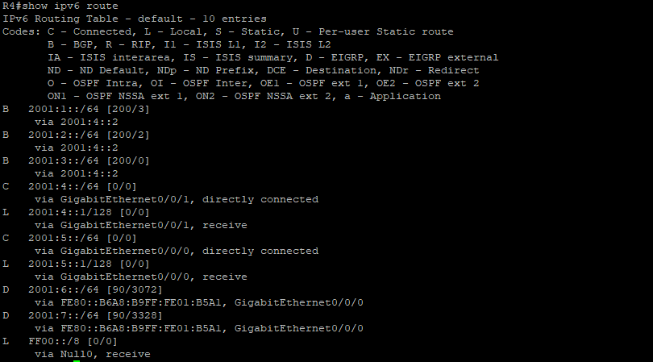  
*Shown below is the entire IProuting table of R6, this tells R6 where to send each packet entering R6; note the different letters next to each entry and that all entries coming from the other AS are marked as BGP routes.*   
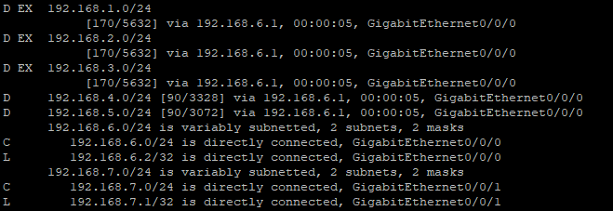  
*Illustrated below is the traceroute from the R6 towards PC1 done to test connectivity across the network.*

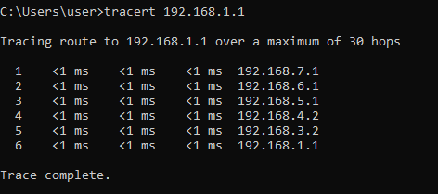

***Problems***

One of our first issues came with redistributing EIGRP routes where routes would not be distributed, to fix this it needs to use the command ‘redistribute EIGRP 1’ required usage of additional specifications of the metric with the entire command needing ‘redistribute EIGRP 1 metric’ specifying the bandwidth, metric, and reliability. One of the largest errors we ran into at the beginning of the lab was using internal instead of external BGP to redistribute routes across the autonomous systems. This was due to believing that the 1 in ‘router bgp 1’ was not used in communications. This 1 turns out to be the ASN used to identify the system. Using the same number for both of the routers means that the routers are using internal BGP, which causes issues with route propagation. To fix this one route was given BGP ASN 2 and all the respective commands were changed.

***Conclusion***

In summary, I gained a greater understanding of the technical applications of BGP across the world and how they are especially usable for exchanging routes between two different internal gateway protocols or autonomous systems. I also, by accident, learned about how BGP can also be used as an ‘internal’ gateway protocol to distribute routes.